Ankur Tandan

Client / Server Dev

Project 2

_________________________________________________________________________

**About the Project:**

This project provides an interactive web dashboard for Grazioso animal shelter operations. The dashboard allows users to filter the dataset of shelter animals to find animals suitable for different rescue operations, such as water, mountain, or disaster rescues. It utilizes a MongoDB database to store animal data and a Python Dash application to present and interact with the data.

**Motivation:**

The motivation behind this project was to help and streamline the process of the animal shelter operations. The business was seeing an increase in traffic and wanted to automate parts of their business to provide an effective service.

**Getting Started:**

Follow these steps to get a copy of the dashboard running:

Installation:

* 1. Ensure MongoDB and Python3 are installed on your system.
* 2. Install the necessary Python libraries, including `pymongo`, `dash`, `dash-leaflet`, and `plotly`: **pip install pymongo dash dash-leaflet plotly**

**Functional Requirements:**

The dashboard fulfills the following functional requirements:

* Display a geolocation map that shows the location of the selected animal.
* Allow users to filter the dataset based on rescue types.
* Show a dynamic pie chart reflecting the distribution of breeds within the selected filter.
* Include the Grazioso logo and a unique identifier for the creator of the dashboard.

Screenshots of the requirements:

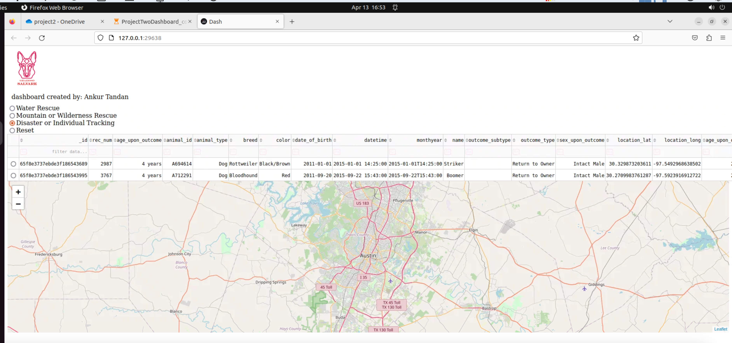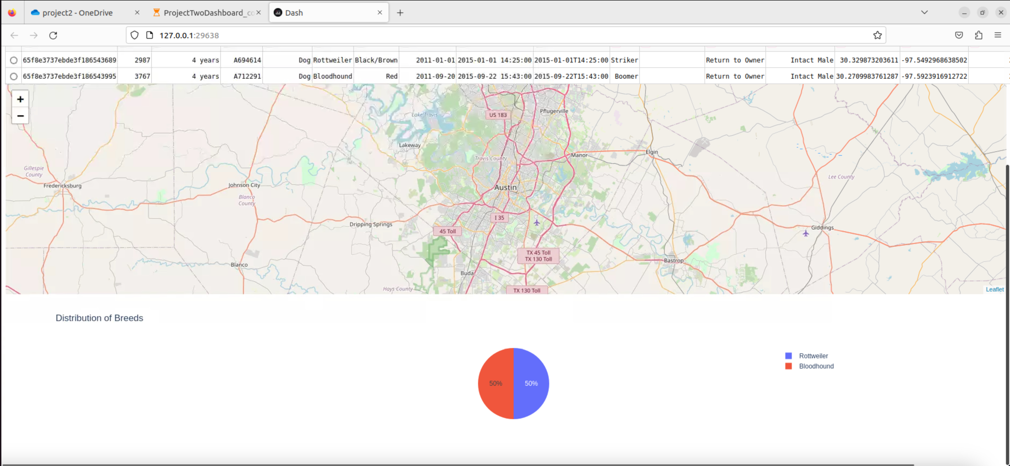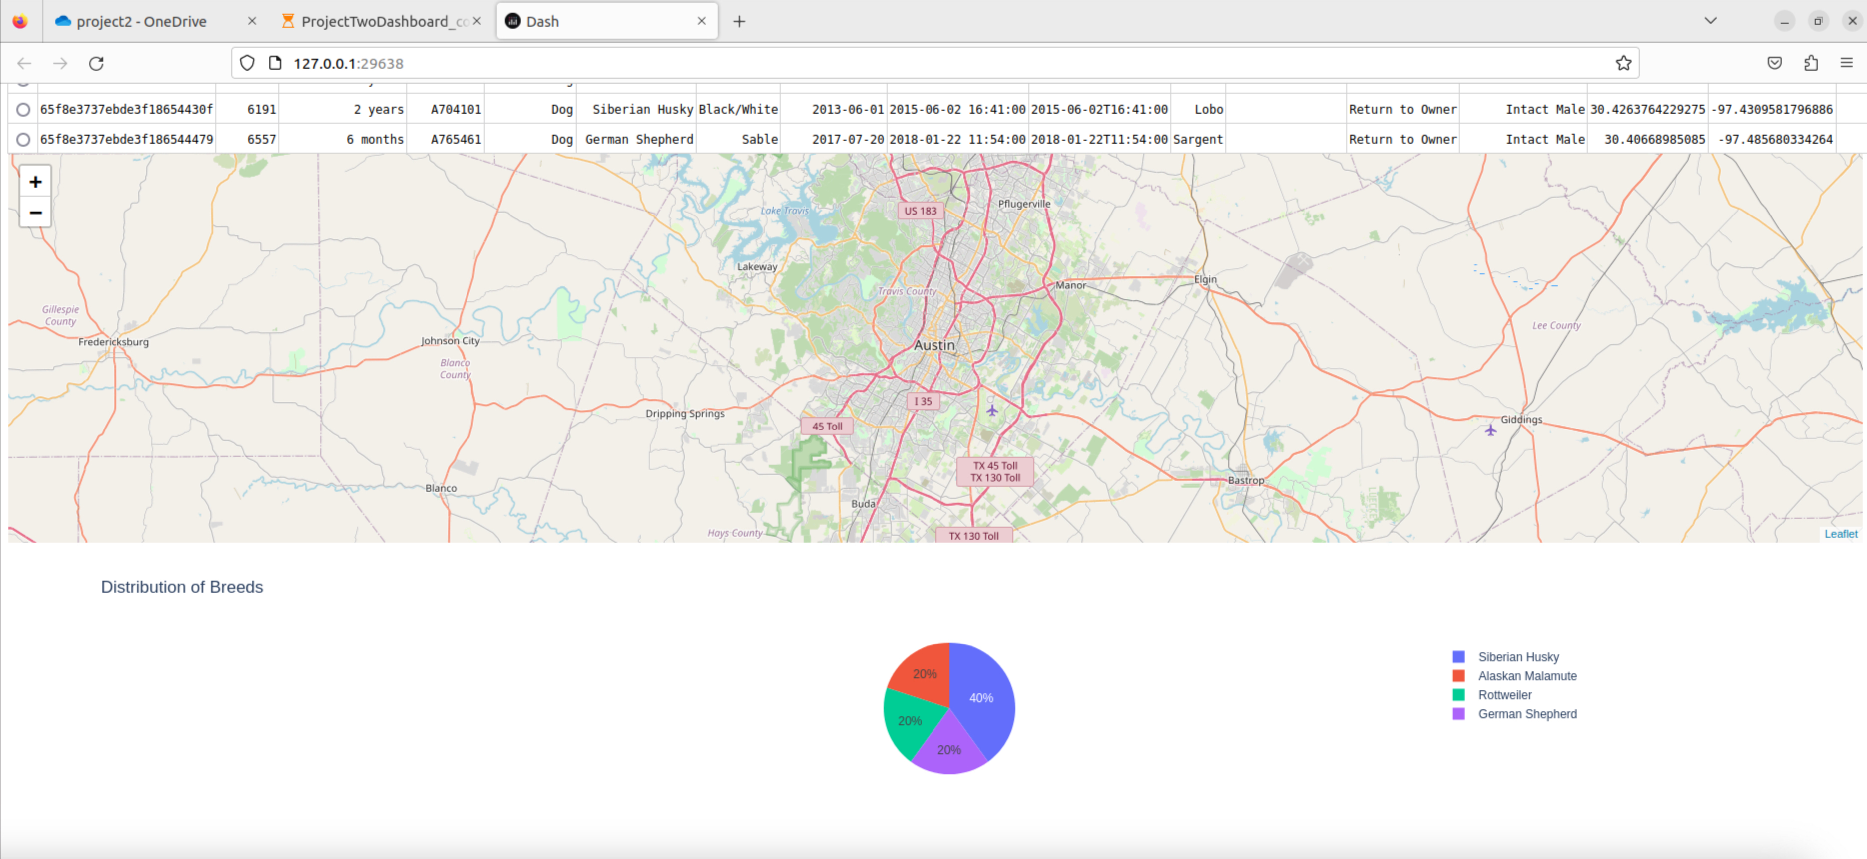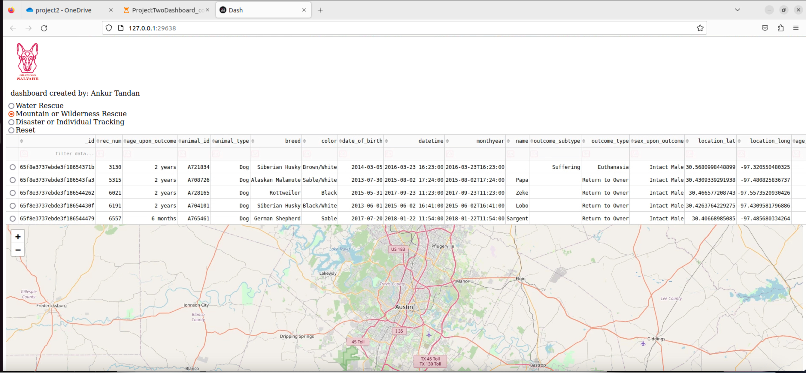

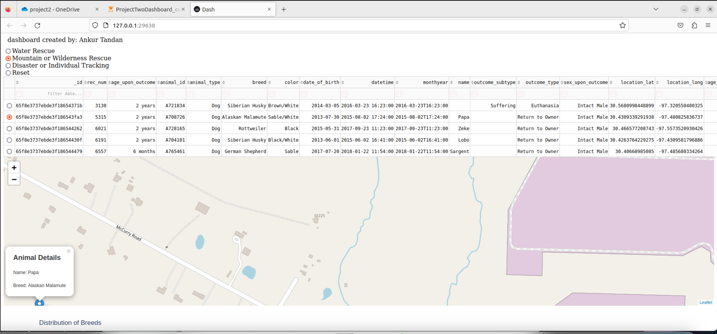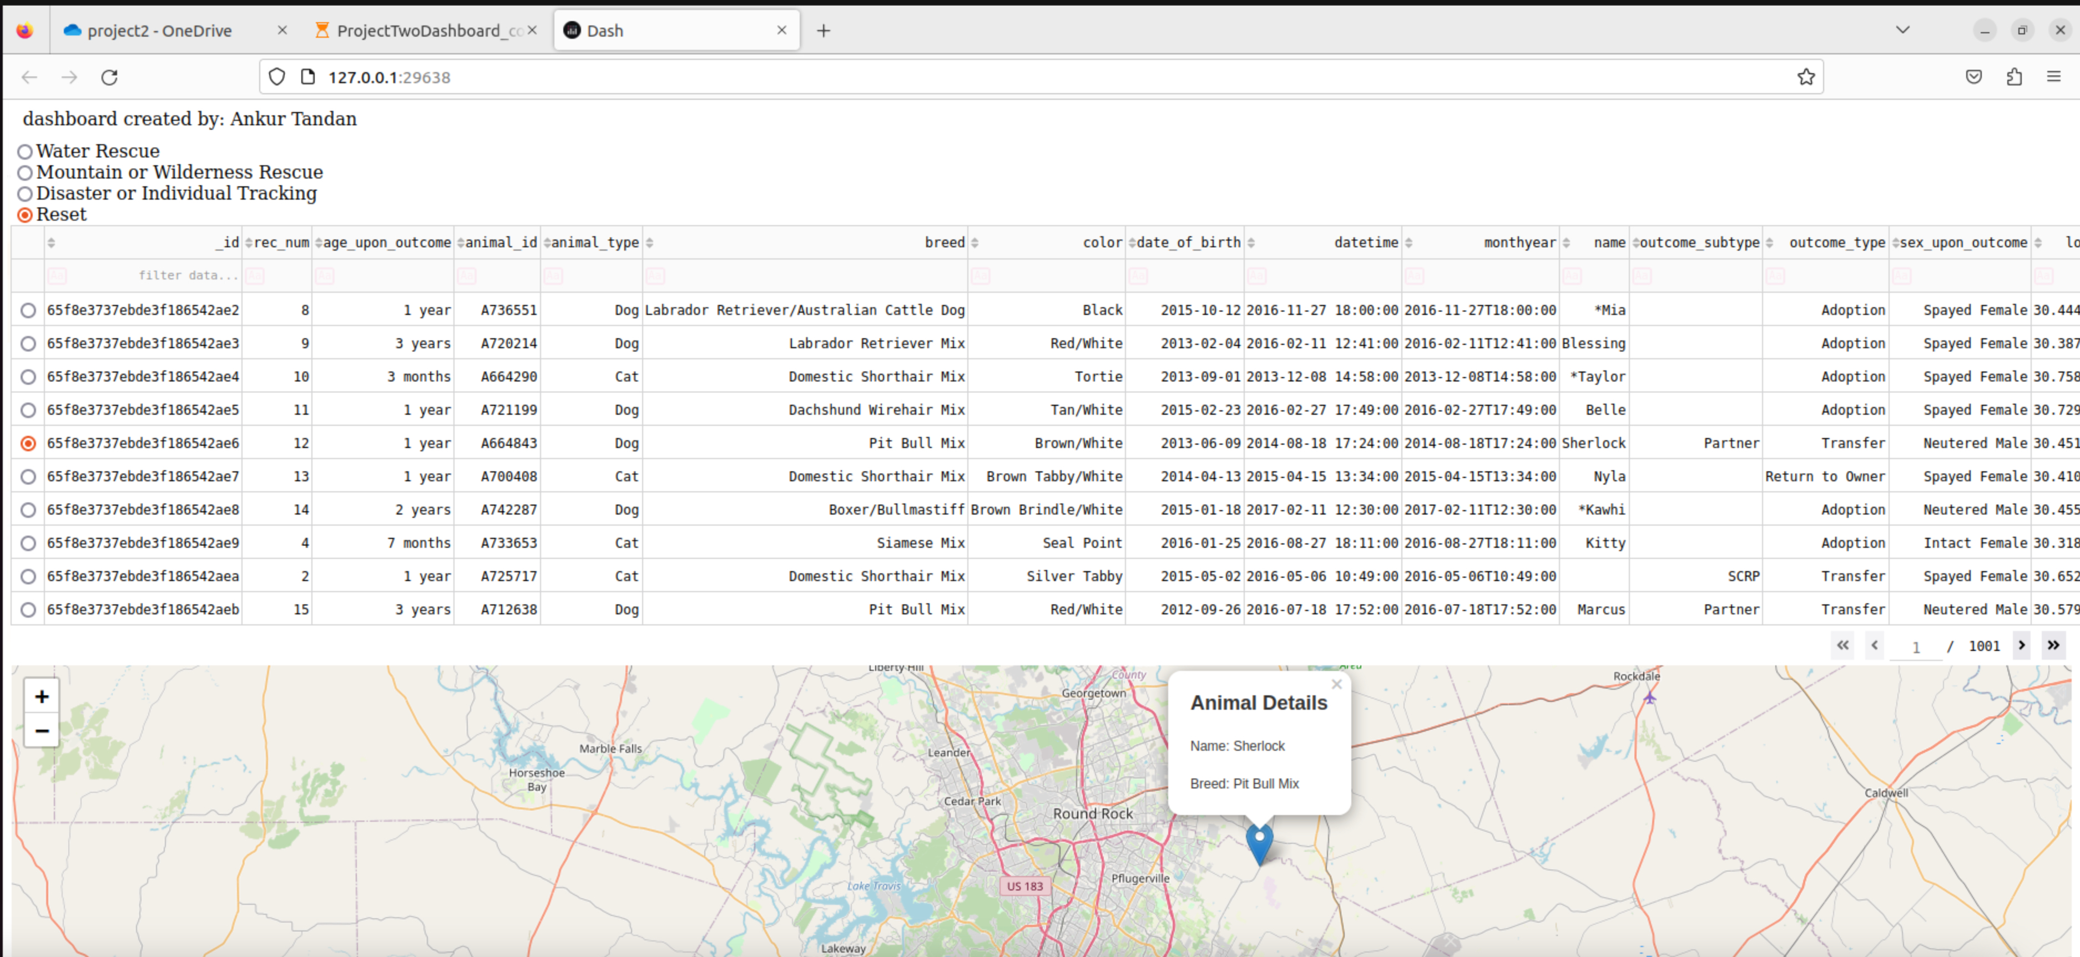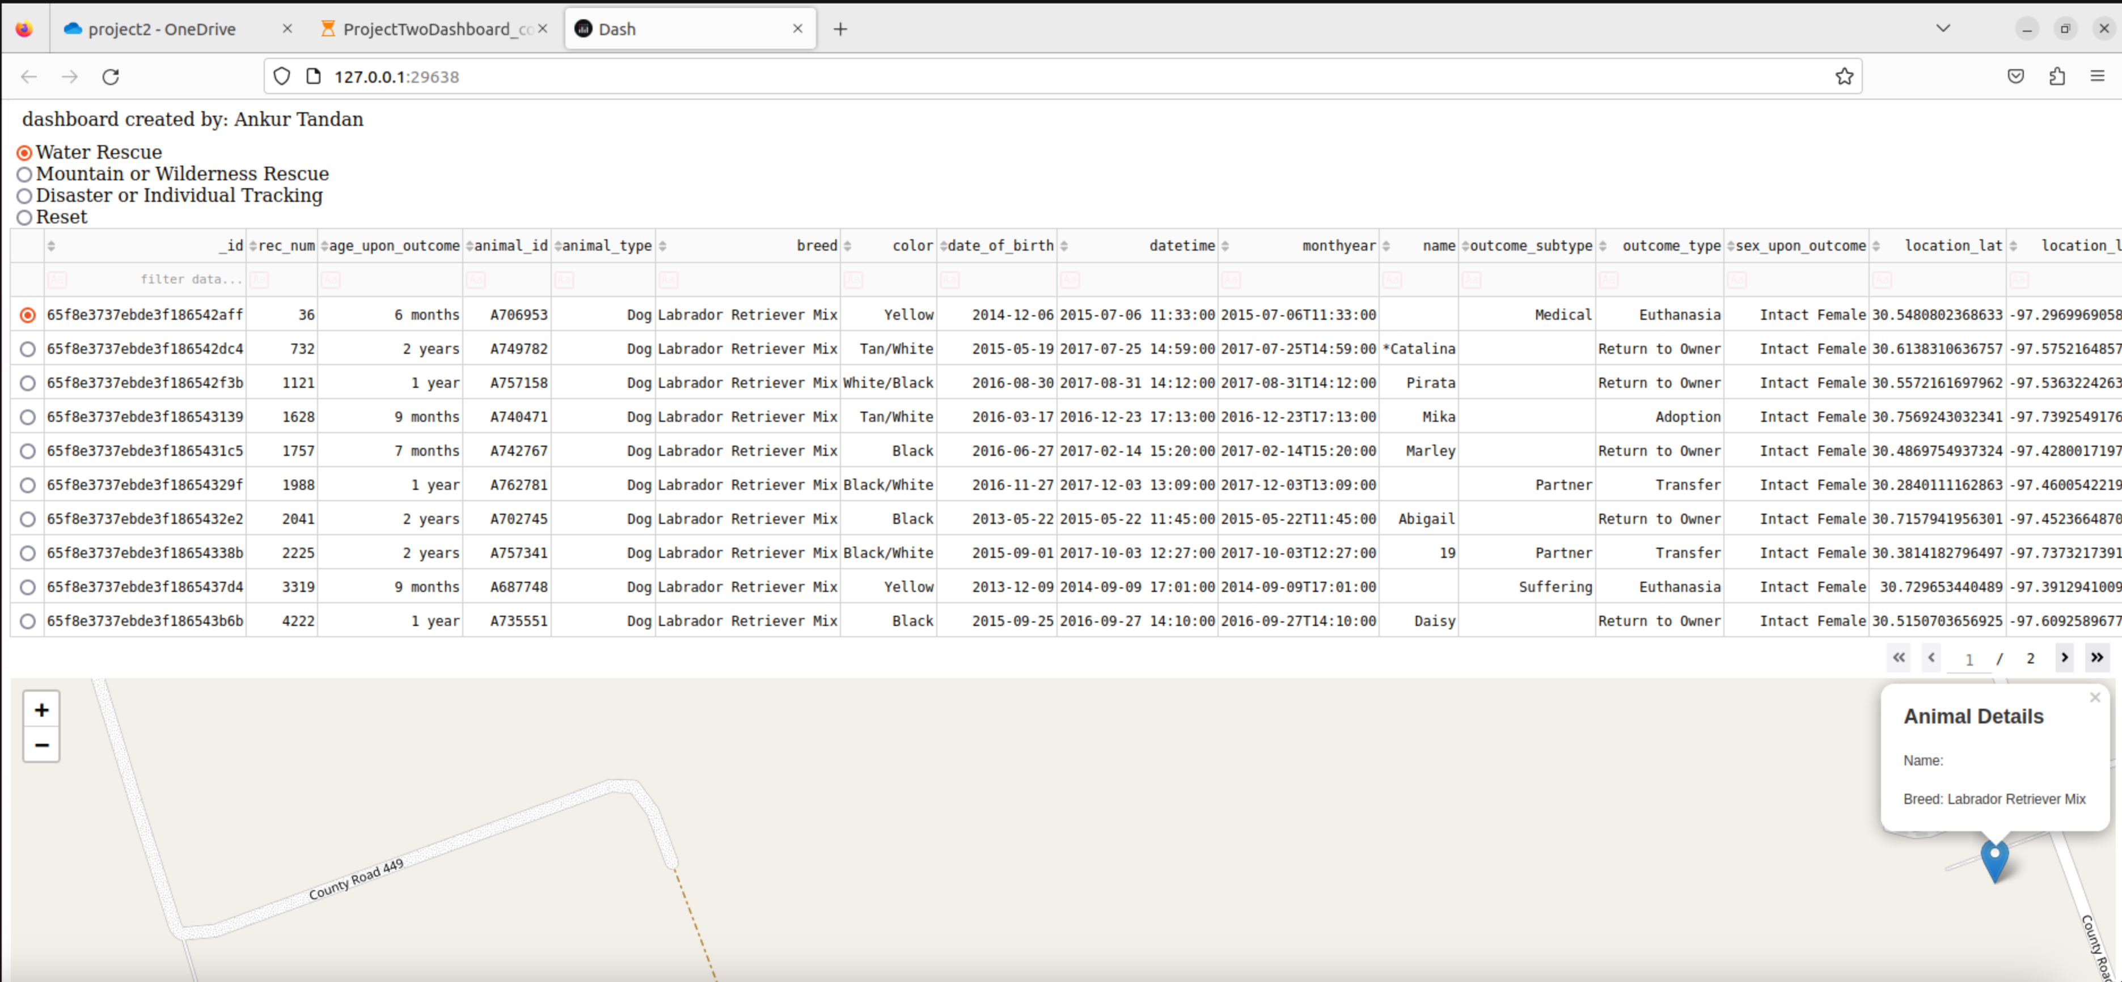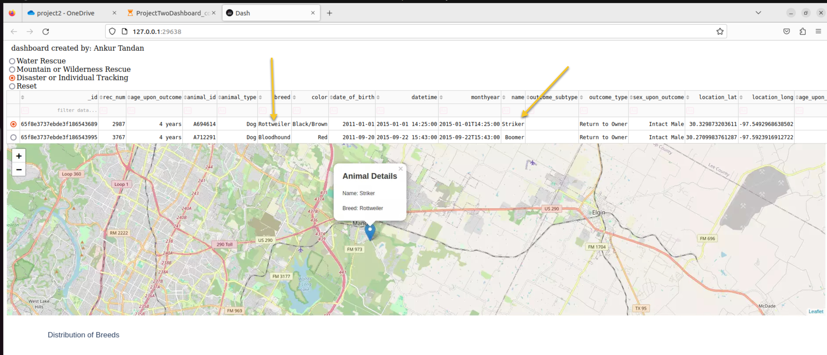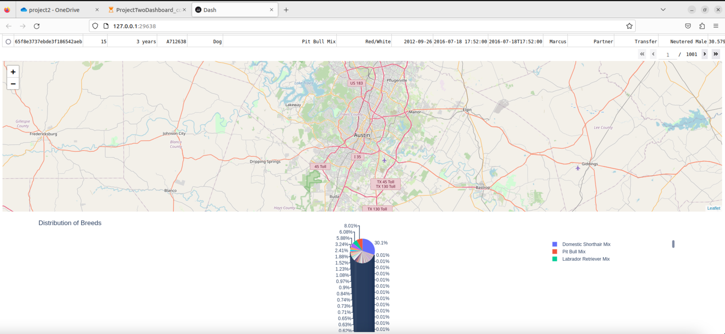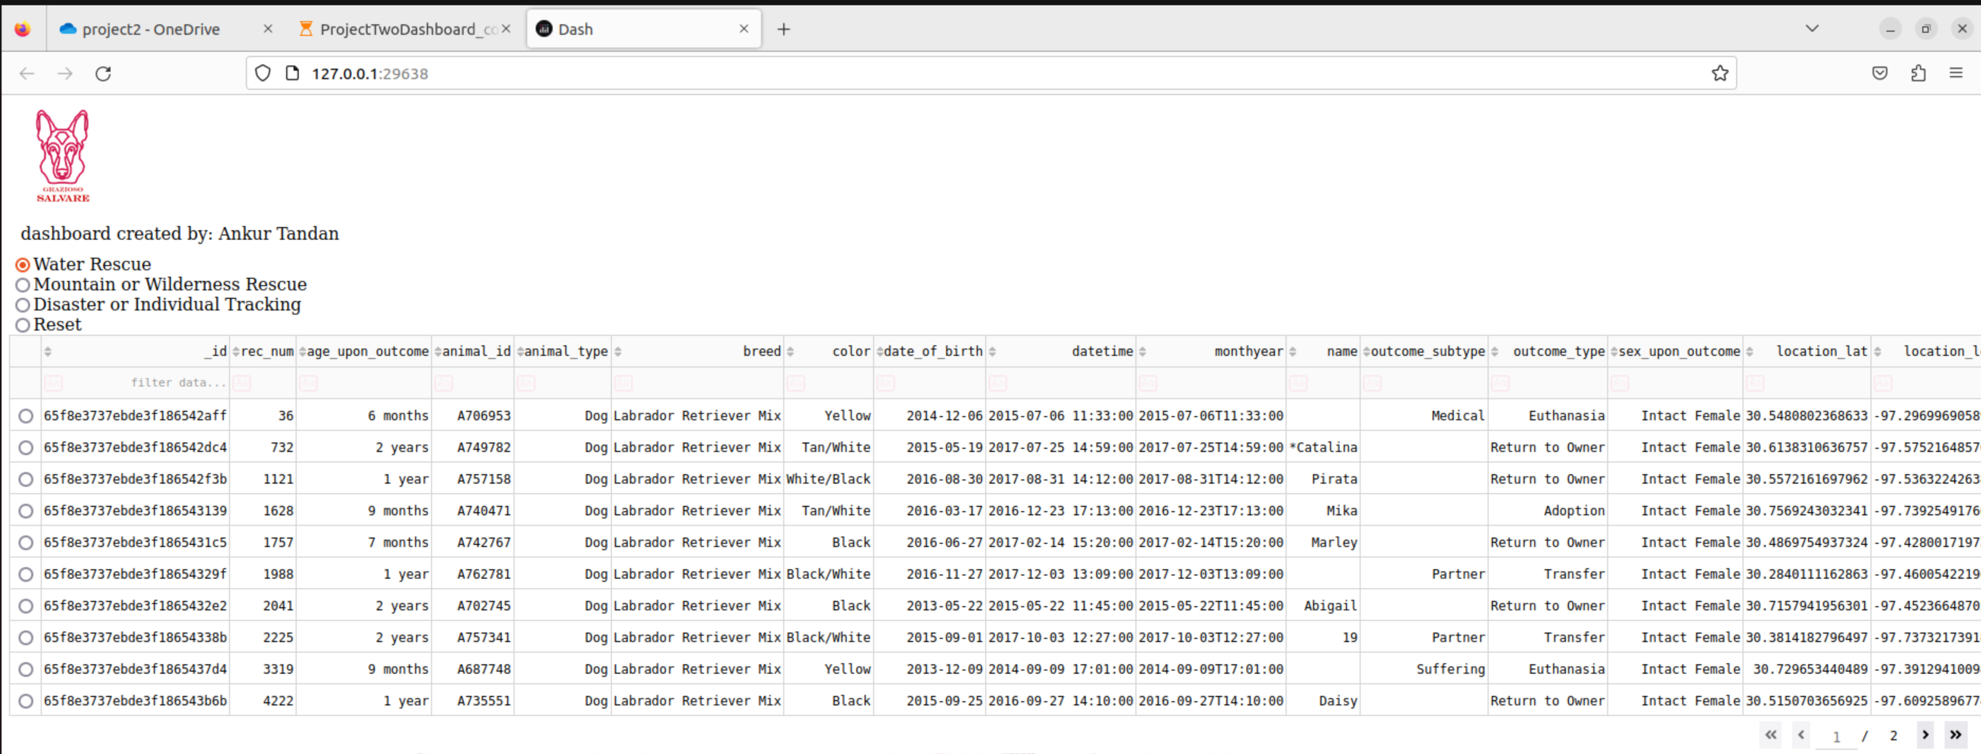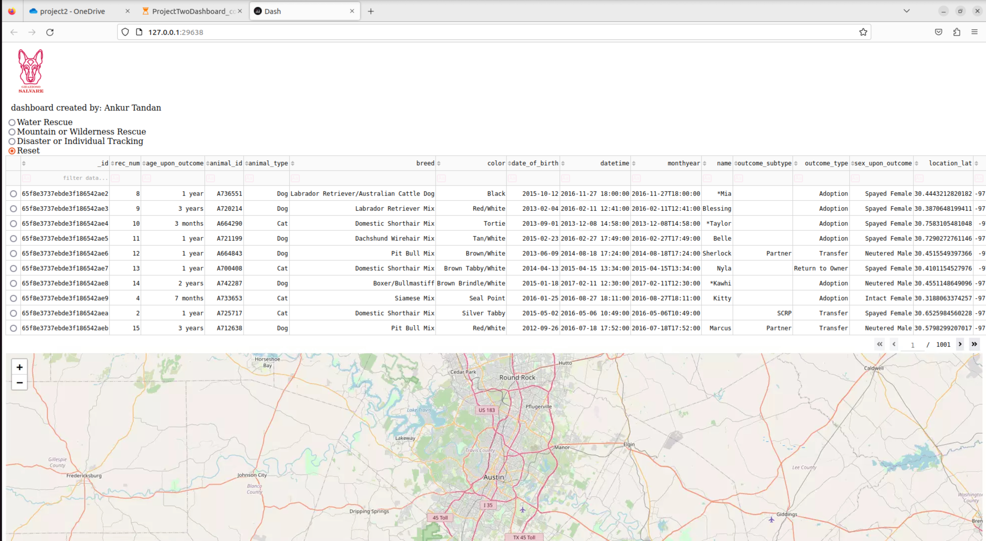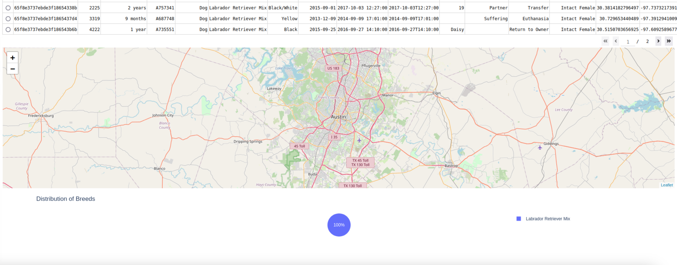Screencast:

[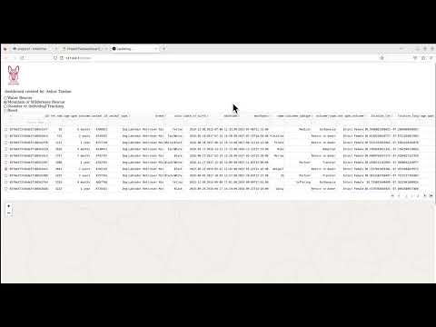](https://youtu.be/crwQV8V9jUo)

**Justification of Tools:**

MongoDB: Chosen for its flexibility with schema design, scalability, and powerful querying capabilities.

Python: A programming language with an ecosystem of libraries for data manipulation and web development.

Dash: A Python framework for building web analytical applications.

Dash Leaflet: Used for integrating leaflet maps that can display geolocation data interactively.

Plotly: Provides visualization capabilities for creating dynamic charts.

**Dash Framework:**

Dash is used as the view and controller, providing a clean MVC architecture. It allows for the construction of a web server with interactive components and a clear separation of concerns, facilitating maintenance and future updates.

**Steps to Complete Project:**

1. Design and implement the CRUD module using Python and MongoDB.

2. Create a Dash app layout with interactive filtering options and data visualization components.

3. Implement callbacks in Dash that respond to user input and interact with the MongoDB database.

4. Test the application to ensure that all components function as expected.

5. Document the project with a README file.

**Challenges:**

Some challenges faced around the interactive components of the projects, such as filtering and using the right key. Also the data allowed needed to be increased within the Jupyter notebook during testing.

_________________________________________________________________________